PLANETARY HEALTH TRANSECT
Route Briefing for Participants

Kathmandu → Chitwan → Pokhara → Lower Mustang (Marpha) → Upper Mustang
This briefing is designed to help participants understand what they will observe while traveling each stretch of the transect. Read the relevant section before departure or during travel. Each section covers what to expect in terms of geography, geology, ecology, climate, settlements, culture, and land use.
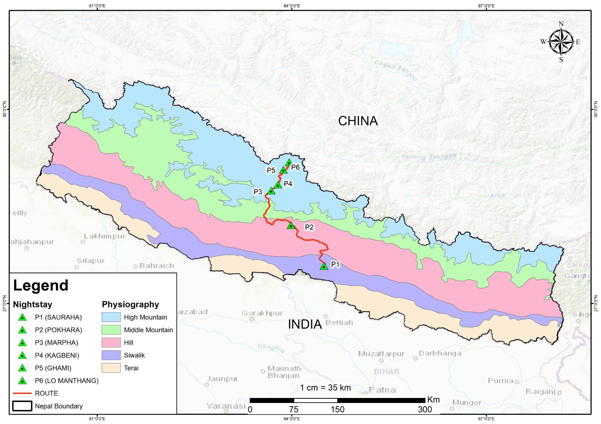

Stretch 3 | Pokhara to Lower Mustang (Marpha)

Landscape & Geography

Pokhara to Beni
Starting in the Pokhara Valley, you experience a broad, fertile landscape characterised by high humidity and the unique geological setting of the Midlands.

The Kali Gandaki Gorge
Fun fact: the Kali Gandaki Gorge which we'll be passing through, is widely considered the world's deepest gorge! As you move north toward Beni and Dana, the terrain becomes increasingly rugged, featuring the extremely high relief and steep slopes of the Higher Himalayan Zone.

The Rain Shadow Transition
North of Kalopani and Ghasa, the landscape shifts abruptly as you enter the trans-Himalayan rain shadow. The dense forests of the southern slopes give way to a semi-arid desert appearance with dramatic cliffs, caves, and barren ridges.

Marpha Village (2,667 m)
In Marpha, the valley floor broadens between the towering peaks of Annapurna and Dhaulagiri. The landscape is defined by fields of reddish buckwheat, apple orchards, and traditional stone architecture that resembles cliff-dwellings.

The Beni–Jomsom Road
The journey from Pokhara to Marpha represents a dramatic transition through the main Himalayan range, moving from lush midlands to a rain-shadow desert.
- Geographical Changes: Starting in the water-rich Midlands near Pokhara, the road travels north toward Beni, which serves as the gateway to the Kali Gandaki valley. As you move north of Ghasa, the valley floor broadens, and the atmosphere takes on a new luminosity typical of desert country.
- Geological Views: This route offers a spectacular cross-section of three geological zones. From Beni to Dana, you observe soft rocks like phyllites and slates. North of Dana, you enter the Higher Himalayan Zone, characterised by extremely high relief and steep rock slopes. Near Marpha, the Tibetan-Tethys Zone becomes dominant, featuring soft contours and hills covered with reddish-coloured stones.
- Ecological Shifts: You move from subtropical and temperate forests into a semi-arid desert. In Marpha, the landscape is defined by apple orchards and fields of reddish buckwheat.

Slopes & Hazards
The southern section (Beni to Ghasa) is highly prone to water-induced landslides, soil erosion, and debris flows during the monsoon. A critical hazard zone exists at Rupse Chhahara, where past landslides have destroyed buildings and threatened the trail. North of Ghasa, hazards shift from water-induced slides to strong thermal valley winds that resuspend heavy dust.

Climate
You travel from the subtropical and warm temperate zones of Pokhara into the cool temperate zone of Lower Mustang.
- Precipitation Drop: The most significant climatic change is the move from one of the wettest regions in Nepal to one of the driest. Pokhara receives approximately 3,800 mm of annual rainfall, (up to 5,600 mm in Lumle) whereas the area around Marpha and Jomsom receives less than 250 mm.
- The Daily Valley Wind: Travelers will experience a unique thermal phenomenon: strong, daily valley winds that blow northward through the Kali Gandaki starting around midday. These winds frequently resuspend dust on the dry, unpaved road sections.
- Atmospheric Clarity: As you approach Marpha, the atmosphere takes on a new luminosity and a growing feeling of desert country, reflecting the proximity to the Tibetan plateau.
What to Observe: At some point north of Ghasa, the green simply stops. Try to spot exactly where it happens — it is surprisingly sudden. The same clouds that bring heavy rain to Pokhara cannot cross the mountains, so the land on this side stays dry. You may also feel the wind pick up around midday; this is a daily pattern in this valley, not just weather. Near Marpha, look for the apple trees and the distinctive reddish colour of the buckwheat fields and surrounding hillsides.

At-a-Glance Summary
Feature | Pokhara (Midlands) | Marpha (Lower Mustang)
Topography | Fertile valley with high rainfall | Broad Himalayan valley in a rain shadow
Climate | Subtropical to Warm Temperate | Cool Temperate and Semi-Arid
Precipitation | Extremely high (~3,800 mm/year) | Very low (<250 mm/year)
Landscape | Lush greenery and lakes | Barren ridges, caves, and buckwheat fields
Key Experience | Monsoon rain and humidity | Strong thermal winds and dust

